
School of Advanced Technology

Individual Portfolio

SAT101 AI Application Design

Student Name: | Churui Yang | Student ID: | 2472765
Portfolio Part: |  |  | 2

My Reflection
My project aims to build an AI-based wearable device called “Brighter”, a smart navigation assistant for visually impaired people. The system combines computer vision, machine learning, and voice interaction to help users detect obstacles and receive spoken guidance in real time. The main tools I plan to use include Python, OpenCV, and PyTorch for image recognition and model development. For the speech part, I will use pyttsx3 or Edge TTS to make the device speak naturally. I will work in a Linux-based environment because it is lightweight and suitable for running on small computers such as Raspberry Pi, which can act as the brain of the device.
After exploring several open-source projects, I found that many researchers have already built AI glasses for blind users. For example, one GitHub project called AI-Glasses-for-Navigation uses YOLOv5 for detecting objects and converts the results into voice alerts. Another one, DeepWay, adds sensors like ultrasonic modules to improve distance accuracy. However, this model is heavy and runs slowly on small devices, so I will not include that part. Instead, I plan to use a smaller model like YOLOv8-Nano, which keeps good speed and accuracy. I will also avoid using extra sensors at the beginning because the camera and model alone can already give enough feedback. This balance shows that my plan is realistic and based on careful comparison.
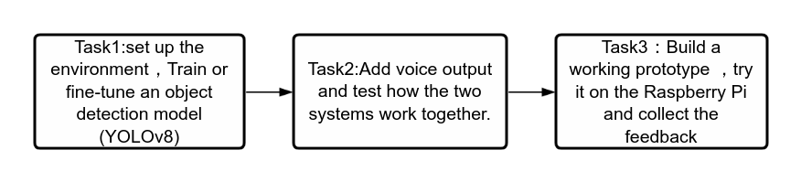
The project will follow a clear and structured timeline that aligns with the methods and models I have chosen. After completing my initial research and the setup of environment, I will begin building a prototype that integrates a computer vision model (such as YOLO) into a small hardware platform like a Raspberry Pi. In the following stages, I will focus on testing, improving the model’s accuracy, and designing a user-friendly interface for real-time navigation assistance. This plan ensures that my work develops step by step, from understanding theory to creating a practical AI application. The project will follow this simple timeline, each task takes two weeks.
Figure 1. project timeline
The application design itself prioritizes simplicity and accessibility. The core interaction model is straightforward: users wear the glasses and receive real-time audio feedback about their environment. The glasses feature a lightweight front-facing camera that continuously captures the user's surroundings, along with bone conduction speakers that deliver audio without blocking ambient sounds. A single touch button on the temple enables users to activate specific functions.
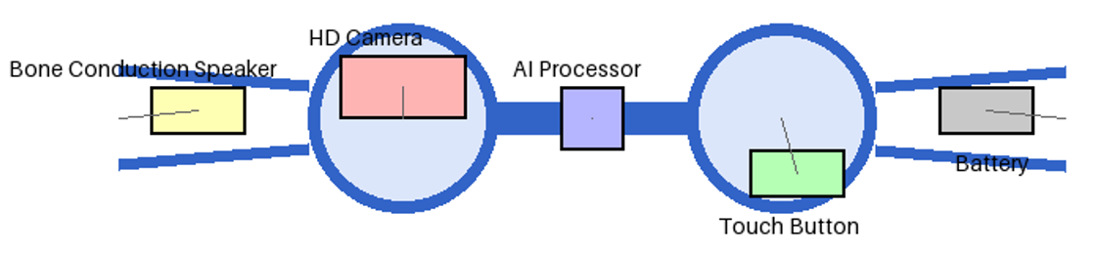

Figure2: Physical Design Draft of AI Glasses
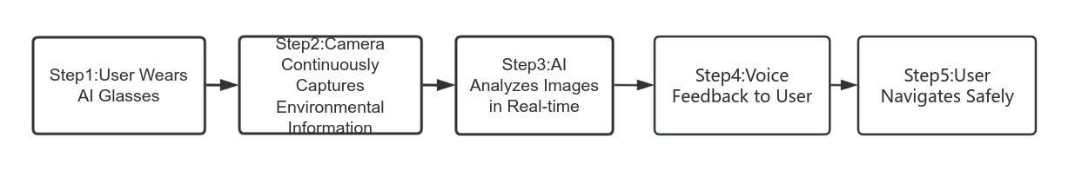
For the user interface, the interaction is entirely voice-based for the wearer. They can ask natural questions like "What's in front of me?" or "Read the sign." Additionally, there is a companion mobile app for caregivers that shows the camera view, system status, and settings using large buttons and high-contrast colors. This design focuses on delivering essential information quickly and clearly, without overwhelming users with unnecessary details.
Figure3:User Interaction Flowchart

Between October 12 and November 1, I have focused on improving my technical skills and knowledge. I read several papers about AI navigation and assistive technology for the visually impaired. I also studied GitHub projects to understand their structure and tried to run parts of YOLO models on my laptop. In addition, I started learning how to use Linux commands and how to install PyTorch in that environment. Even more to the point, I accomplished a task that I had always wanted to do but never took action on before. I practiced machine learning through several hands-on projects on Kaggle, which helped me apply theoretical knowledge to real datasets and strengthen my understanding of model training and evaluation. This period helped me gain more confidence in combining AI models with small hardware systems.
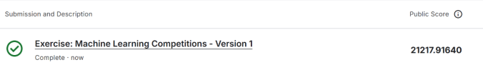

Figure4:evidence of your skill development
Looking back on my progress, I have realized that developing this project requires both software and hardware knowledge. At first, I only wanted to focus on AI algorithms, but now I understand that real success depends on system integration, device optimization, and real-world testing. I also noticed that the project will need access to a large data set to improve accuracy and may even require cloud storage later. These new challenges have changed how I plan my next steps. I will continue to study embedded systems and test the product personally to ensure it truly helps users. This reflection makes me appreciate how AI can connect technology and social responsibility.

